Name – Akshat Bhargava

Roll no – 22563

DS – SL3

Prac 1

Code:

1. Import all the required Python Libraries



2. Load the Dataset into pandas dataframe.

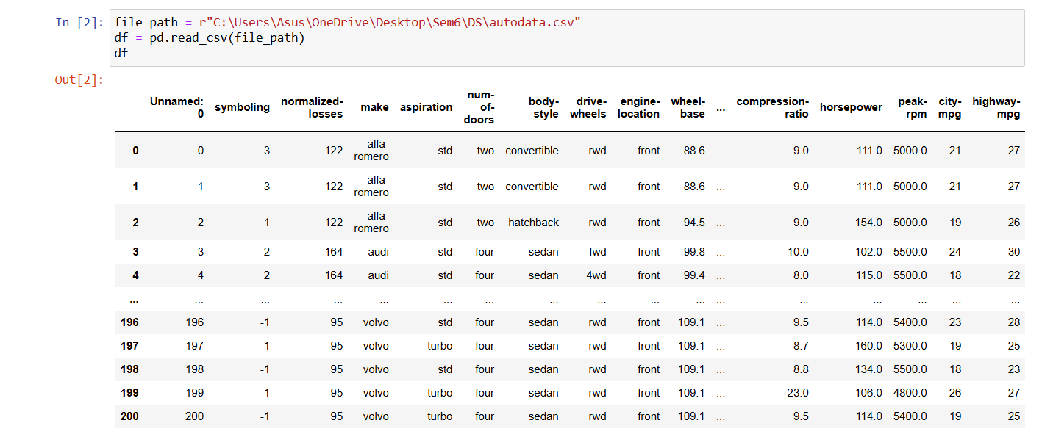

3. Data Preprocessing: check for missing values in the data using pandas isnull(), describe() function to get some initial statistics. Provide variable descriptions. Types of variables etc. Check the dimensions of the data Frame.

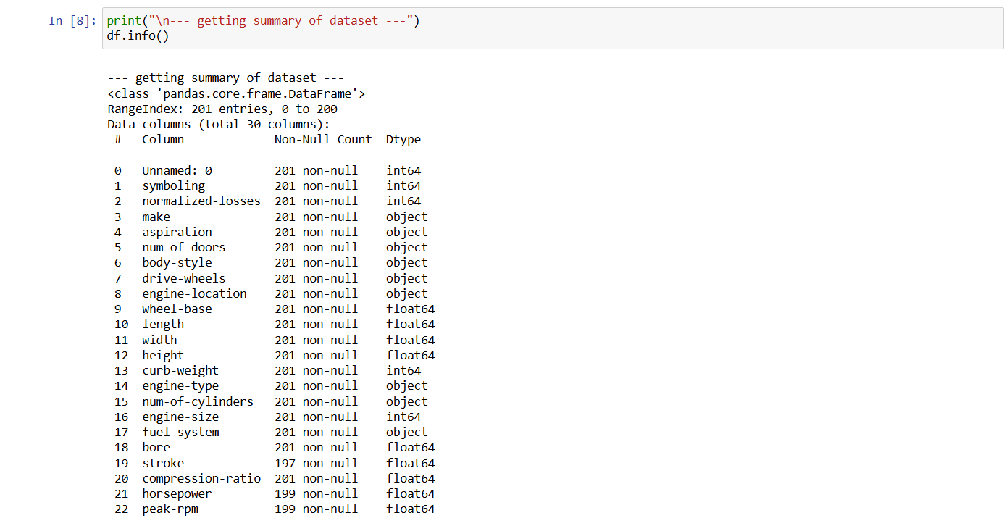

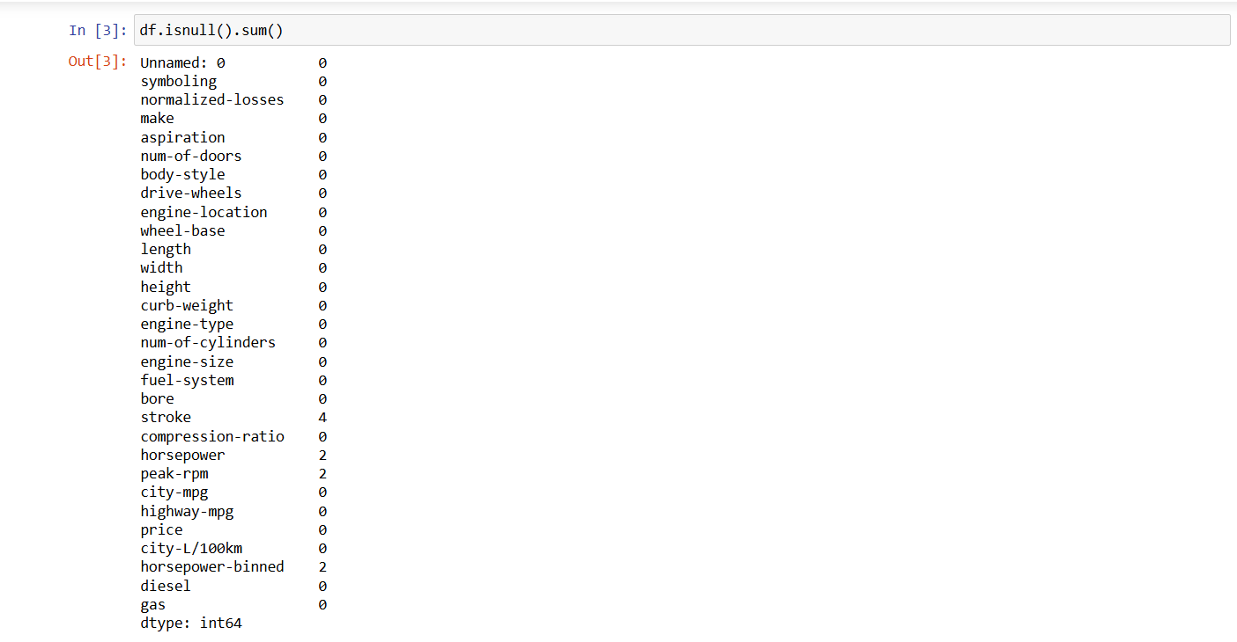

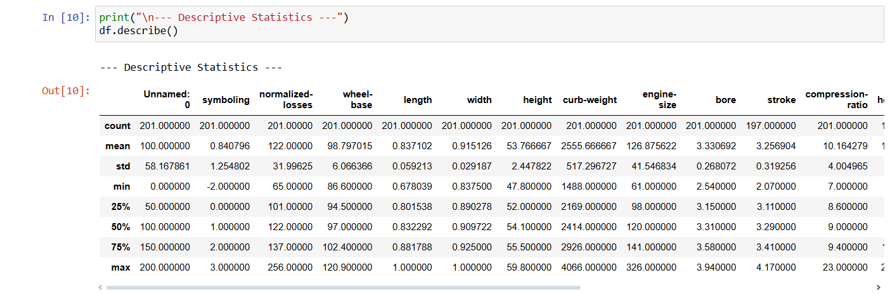

4. Data Formatting and Data Normalization: Summarize the types of variables by checking the data types (i.e., character, numeric, integer, factor, and logical) of the variables in the data set. If variables are not in the correct data type, apply proper type conversions.

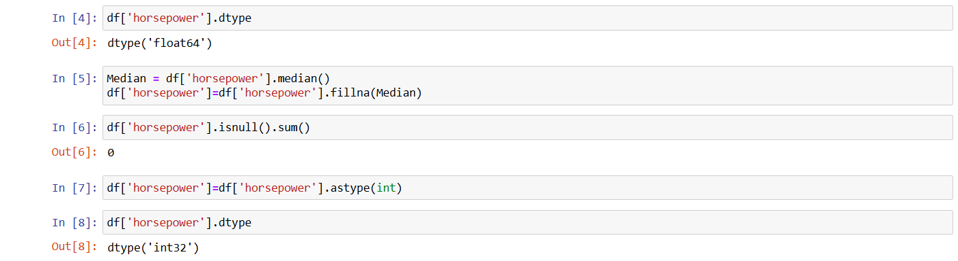

5. Turn categorical variables into quantitative variables in Python.

